Second Sunday in Ordinary Time
Sunday 18 January 2026

LITURGICAL CALENDAR
For the current week’s readings and Saints please look at The Liverpool Ordo, Liturgy Office www.liturgyoffice.org.uk and Universalis (Liverpool/IOM).

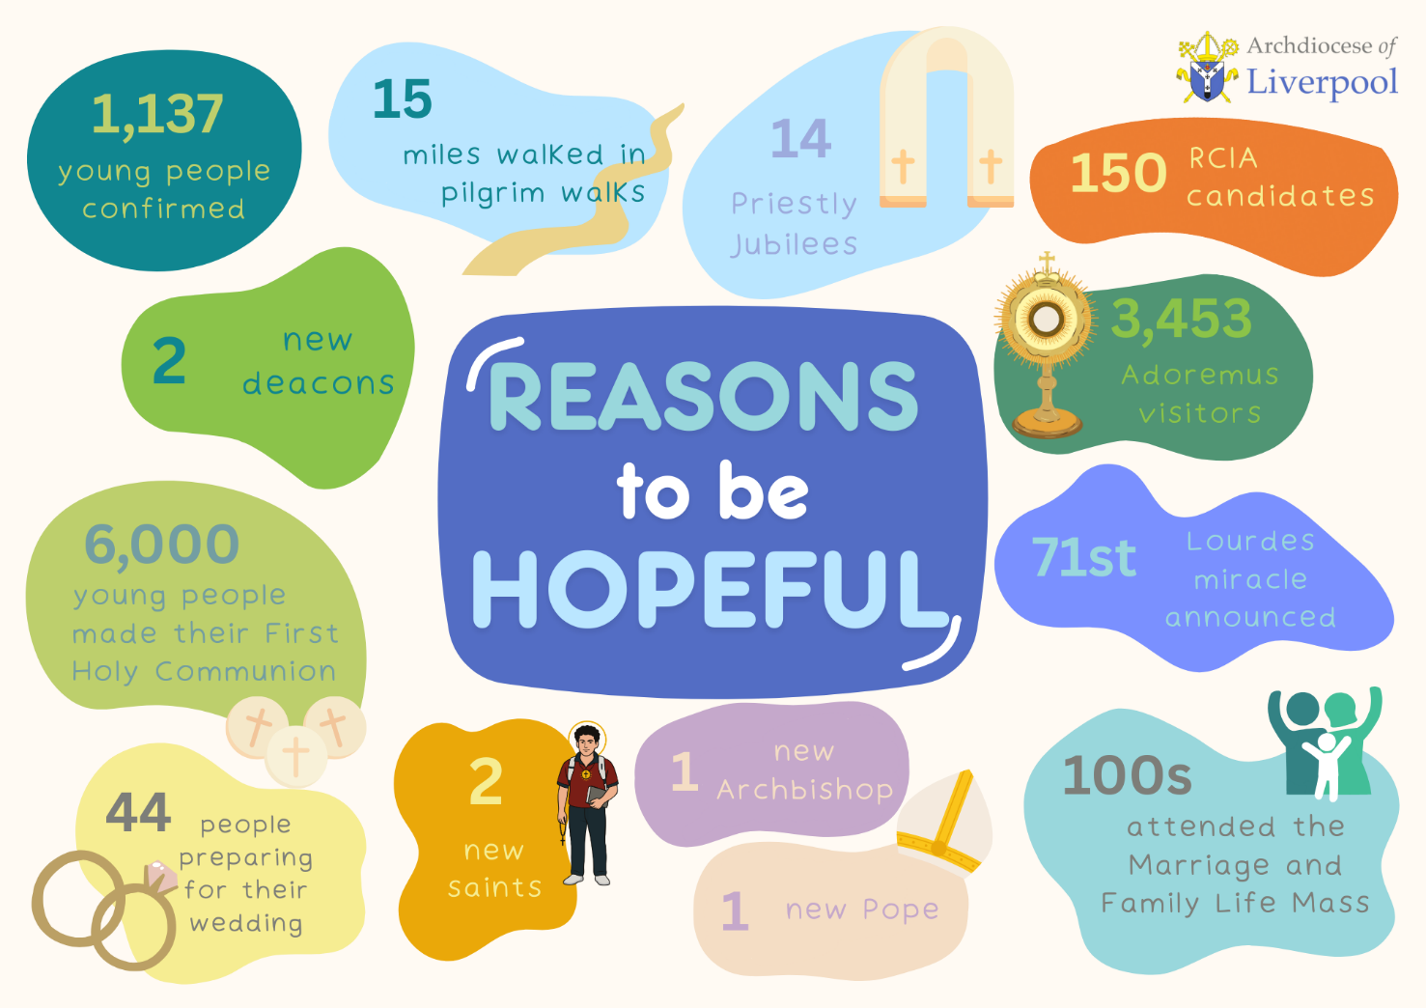

SACRAMENT - CATECHESIS – FORMATION
- LIVERPOOL ARCHDIOCESE ONLINE ALPHA COURSE
The Archdiocese of Liverpool is hosting an 11-week online Alpha course for anyone curious about life, faith, and meaning. It’s a chance to meet new people and explore the Catholic faith in a friendly, open environment - no pressure, no judgement. Sessions run every Thursday at 18:45, from 15 January to 26 March. Each week we tackle big questions about life and faith, sparking great conversations. Sign up today!  Scan the QR code or follow the link to sign up. For more information, please email pd@rcaol.org.uk. | 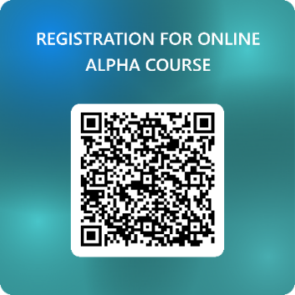

- ADVENTUROUS ACCOMPANIMENT WORKSHOP
Are you a DSC member, a chaplain or a catechist? Have you ever thought about how can you increase the awareness and confidence towards becoming an Adventurous Accompanier?
Through the journey of a 6-week programme including 3 full-day workshops, you will not only explore the core principles of accompaniment but also going in-depth to embed those principles in practice.

All costs of the programme will be covered by the Archdiocese. Please register online if you are interested. Sign up here https://forms.office.com/e/bE7TndtW9p?origin=lprLink
For enquiries, please contact Moses Mui, Training Coordinator at m.mui@rcaol.org.uk
You will choose either one workshop for each weekend when you sign up | 
  First Workshop
  Saturday 7 February or Sunday 8 February
  Second Workshop
  Saturday 28 February or Sunday 1 March
  Third Workshop
  Saturday 21 March or Sunday 22 March
  *All Saturday workshops will take place at St Margaret Clitherow Centre, Liverpool, L17 1AA (10:00-14:00)
  All Sunday workshops will take place at St Joseph’s Church, Penketh, Warrington, WA5 2BB (12:00-16:00)

- ‘OLD AND NEW’ REFLECTIONS ON THE GOSPEL OF MATTHEW
Hosted by the Irenaeus Project (Great George’s Road, L22 1RD), reflections will be Wednesday mornings (10:30-12:00) on 14, 21, 28, January and 4 February. Zoom links are available from jenny@irenaeus.co.uk

- COME BACK TO ME WITH ALL YOUR HEART: A SILENT RETREAT
Led by Sr Moira Meeghan at the Irenaeus Centre (Great Georges Road, L22 1RD) from 18:00 Friday 20 February – 13:00 Sunday 22 February. Those interested are advised to book early: residential places are £95, non-residential with meals is £70, non-residential (self-catering) is £30. To book and for more information please contact jenny@irenaeus.co.uk or call 01519491199.

- LIGHT OF TRUTH: DISCERNING THE WILL OF GOD (Online Formation)
A session to understand how to discern the will of God in every circumstance of life. Held Friday 13 February 19:00-20:00. Short Courses | Light of Truth

- LIGHT OF TRUTH: SHOWING REVERENCE TO GOD (Online Formation)
A session to explore the virtue of religion and how to practice it in the liturgy of the Church and in our daily life. Held Friday 13 March 19:00-20:00. Short Courses | Light of Truth

- FCJ: INTERNATIONAL READING GROUP (ONLINE)
Join the FCJ’s International Reading Group and explore current thinking in Christian churches, ecology, spirituality, and theology. Every Friday at 16:00 (UK time) the group will hold a short recap, discussion, and plenary. The group are currently reading “The Tears of Things: Prophetic Wisdom for an Age of Outrage” by Richard Rohr. No need to attend every week – just join when you can. To receive the link, please email: fcjcentresthughs@gmail.com

- FCJ: FORMATION IN CHRISTIAN LEADERSHIP
This online programme is designed for young adults who wish to use their gifts and talents in the service of others. Beginning on Tuesday 27 January 2026 at 18:00, the programme will run over three months and include three online workshops, reflective activities, personal accompaniment, and practical experience. Participants will be encouraged to cultivate an attitude of generosity and gratitude for their gifts, be actively involved in their local parish or faith setting and commit to attending all sessions. If you would like to learn more about the programme or have a conversation about whether this is for you, please email Sr Lynne FCJ at fcjcentresthughs@gmail.com

- FCJ PILGRIMAGE TO LINDISFARNE
Beginning on Wednesday 8 April (17:00) and concluding Sunday 12 April (14:00), the FCJ’s are inviting all young adults (20’s and 30’s) to a walking retreat to the Holy Island of Lindisfarne, a tidal island off the coast of Northeast England. Walking in the footsteps of the Northern saints, the trail will include a two-day walk on St Cuthbert’s Way, crossing the pilgrim route to the island. One day in Lindisfarne and the final day will include Mass and a visit to St Cuthbert’s Shrine at Durham Cathedral. Accommodation is a Bunkhouse on the mainland with simple facilities, bunkbeds, an open fire and some storage heating. Each day the group will drive to the start of the walk and arrange to be collected form the end. The terrain is open countryside so good walking shoes, a backpack and waterproof jacket are essential. The group will pray together every day with some opportunities for Mass. Complete the form to register

- RACIAL JUSTICE SUNDAY, SUNDAY 1 FEBRUARY 2026
Racial Justice Sunday 2026 is devoted to the promotion of racial justice in our Catholic parishes across England and Wales and society and an encouragement to be conscious of the need for justice in all its forms. For more information, please follow the link

- MARRIAGE WEEK
Marriage Week is an annual celebration offering the opportunity to support and promote marriage and family life. It is celebrated from 7-14 February. For more information, please follow this link

- CONFIRMATION REGISTRATION IS OPEN
We encourage all young people who wish to be confirmed next year to visit the Liverpool Called website with their parents/guardians. The details you provide the online form will be shared with the Dean of the area of which you have applied, your local parish, and the Diocesan administration team. It may be shared with other parties associated with Diocesan sacramental preparation and relevant and appropriate Diocesan bodies and authorities.

Your local parish will be in touch after registration period ends on the 13 February (you will not be contacted beforehand) with details about meetings in your local area. You will likely be contacted after Easter. Please do not worry if you are not contacted immediately. If you have any queries, please contact your parish priest.

The information you provide will be held for the sacramental year (which ends on the day new application forms go online for the succeeding sacramental preparation year) and your
contact information may be used to contact you by email, text, letter or phone.
For more information on how your data may be used and our retention policy please see https://www.liverpoolcatholic.org.uk/privacy

- MARRIAGE AND FAMILY LIFE MASS
Archbishop John Sherrington will celebrate the Marriage and Family Life Mass at the Metropolitan Cathedral of Christ the King on Sunday 8 February 2026 at 11:00. The Mass will include the renewal of marriage vows and a special blessing for those celebrating significant anniversaries. Refreshments will be served afterwards in the Gibberd Room. For those couples who are celebrating a significant wedding anniversary, please register online for a certificate which will be collected on the day. Register here https://forms.office.com/e/uE6amHrQ6w?origin=lprLink  For more information, please contact Moses at: m.mui@rcaol.org.uk | 

  - MARRIAGE PREPARATION CATECHISTS NEEDED
Would you like to help engaged couples to prepare for marriage? The archdiocese is now recruiting catechists to join the marriage preparation team. The catechist training will be provided at St Monica's Church, Bootle, Liverpool, L20 9GA and consists of 5 sessions:
    - Monday 23 February 2026 (6.30pm – 8pm)
    - Monday 2 March 2026 (6.30pm – 8pm)
    - Monday 9 March 2026 (6.30pm – 8pm)
    - Monday 16 March 2026 (6.30pm – 8pm)
    - Monday 23 March 2026 (6.30pm – 8pm)
Upon completion of training, the catechists will be asked to offer marriage preparation course for couples twice a year. If this is something you are interested in, please sign up here https://forms.office.com/e/JGbP8AtZwn?origin=lprLink
For more information, please contact Moses at m.mui@rcaol.org.uk

- EUCHARISTIC MINISTRY TRAINING DAYS
The Irenaeus Centre will be leading a Eucharistic ministry training day on 14 March 2026. For more information and Zoom links, parishes are invited to book by emailing jenny@irenaeus.co.uk

- RE-IMAGINING PASTORAL COUNCILS WEBINAR SERIES
In our crazy changing world, it’s more important than ever that our parishes can respond to people’s needs and share the Gospel in our local communities. Pastoral Councils, rooted in prayer and driven by mission, can be places of discernment and real creativity – but sometimes they’re not quite right. Join us for a series of webinars to explore everything to do with pastoral councils from purpose to membership, and from resolving conflict to letting the Spirit lead.

Would you like to explore a new approach for your Parish Council?
Would you like to set up a Parish Council for the first time?
Would you like support in ensuring your current Parish Council is fruitful, spiritual, and life-giving?

This is a joint project between the RC Archdiocese of Liverpool and the Dioceses of Hexham & Newcastle and Northampton.

Webinars are Tuesday evenings from 19:00-20:00 (UK time).
Registration is free. The registration link is https://buytickets.at/northamptondiocese/1861328 A one-time registration for all webinars. A link will be sent on the day to each person.

CATHOLIC SOCIAL ACTION
- LIVERPOOL JUSTICE AND PEACE COMMISSION
The Archdiocese of Liverpool’s Justice & Peace Commission invites you to this year’s Peace Sunday Memorial Lecture. In light of Pope Leo XIV’s recent World Peace Day Message, Dr Joanna Frew will speak on "Towards an 'Unarmed and Disarming Peace': Seeking Sustainable Security for an Unstable World.”

This will take place on Peace Sunday: 18 January at 14:00, at St Vincent de Paul, L1 5JN.
All those who wish to deepen their understanding of Pope Leo’s message, and reflect on what it means for us today, are warmly welcome to join us for this lecture.
Please sign-up using the following link:


Peace Sunday Lecture: Peace be with you all- Towards an ‘unarmed and disarming’ peace. – Fill in form

YOUTH/YOUNG ADULTS
- ARCHDIOCESAN YOUNG ADULT GROUP
The Archdiocesan Young Adult Group meet fortnightly at the Pauline Book Centre (Church Street, L1 3AY) in Liverpool City Centre. Anyone aged 18-35 is most welcome. For enquiries, please contact Moses Mui at m.mui@rcaol.org.uk.On Tuesday 20 January (18:30-20:00), the group will meet with Chris Reynolds from Stella Maris to discuss how we can stand in solidarity with seafarers and fishers. To reserve your place please scan the QR code or follow the link: https://forms.office.com/e/Rc8CSK0XbW?origin=lprLink | 

- PORTUGESE-SPEAKING YOUNG ADULTS PRAYER GROUP
Join our monthly gathering for prayer, friendship, and faith at St Michael and All Angels Church, Kirkby L32. All Portuguese-speaking young adults are welcome! For more information please contact: 07752 773037 Tiago and 07857 178601 Karine.

- LECTIO FOR YOUNG ADULTS
Every Friday at 18:00 at St Vincent de Paul's Church, L1 5JN, there is a "lectio" prayer group for young adults. There will be a Mass at 18:00, followed by a short time of sharing the Sunday readings at 18:30. It's a friendly group and sometimes they also organise trips and retreats. Follow this link to join my WhatsApp community: https://chat.whatsapp.com/H7vBavJ4Jlm2spPNI9d2DT If you want more information please contact James: djmoroney@cantab.net or 07546667394
- Register here
- Event details
- Young people in the ecumenical movement

SAVE THE DATE!
Rite of Election Mass | Sunday 22 February
Mission Days | Tuesday 21 April / Thursday 23 April / Saturday 25 April

CONTACTS
If you are concerned about the safety of a child or vulnerable adult and feel they are in immediate danger, please call the police. If you wish to report any non-urgent concerns, please contact your local social services or our safeguarding team direct at


or Mark Robson 0151 522 1013 / 07585761965 Claire Newton 0151 522 1043 / 07384643237 or safeguarding@rcaol.org.uk
CONTACTS: PASTORAL DEVELOPMENT DEPARTMENT (PD) TEAM
pd@rcaol.org.uk https://www.liverpoolcatholic.org.uk/department/pastoral-development
Director of Pastoral Development Liz Parsons e.parsons@rcaol.org.uk 0151 522 1023
Pastoral Development Jonathan McGuirk j.mcguirk@rcaol.org.uk 0151 522 1040
Administrator
Pastoral Plan Administrator Ian Parrott i.parrott@rcaol.org.uk 0151 522 1044
Training Coordinator Moses Mui m.mui@rcaol.org.uk 0151 522 1047
Catholic Social Action Coordinator Lucy Rauer l.rauer@rcaol.org.uk 0151 522 1042
Youth Ministry Coordinator Sarah McGeehan s.mcgeehan@rcaol.org.uk 0151 522 1041
Parish & Deanery Development Chris Higgins c.higgins@rcaol.org.uk 0151 522 1046
Adviser
Episcopal Vicar for Rev Gerard Callacher g.callacher@rcaol.org.uk
Parish Development
Episcopal Vicar for Pastoral Rev Mgr Philip Inch p.inch@rcaol.org.uk
Organisation & Synod
Implementation
Bishops’ Delegate for Sr Lynne Baron, FCJ l.baron@rcaol.org.uk
Catholic Social Action
The Irenaeus Project www.irenaeus.co.uk/
Youth Ministry: Animate www.animateyouth.org/
Do you know someone who would like to receive to our bulletin? Please forward this bulletin to them, or send them this hyperlink to subscribe: https://mailchi.mp/e8bb057375db/sign-up-form

